Maryland Historical Trust Inventory No. PG: 82B-006

Maryland Inventory of

Historic Properties Form

1. Name of Property (indicate preferred name)
historic Sansbury-Griffith House
other
2. Location
street and number 8000 Croom Station Road not for publication
city, town Upper Marlboro vicinity
county Prince George's
3. Owner of Property (give names and mailing addresses of all owners)
name George E. and Geraldine E. Griffith
street and number P.O. Box 341 telephone
city, town Upper Marlboro state MD zip code 20773-0341

4. Location of Legal Description
courthouse, registry of deeds, etc. Prince Georges County Courthouse liber 2587 folio 533
city, town Upper Marlboro tax map 110 tax parcel 63 tax ID number 0203547

5. Primary Location of Additional Data
Contributing Resource in National Register District
Contributing Resource in Local Historic District
Determined Eligible for the National Register/Maryland Register
Determined Ineligible for the National Register/Maryland Register
Recorded by HABS/HAER
Historic Structure Report or Research Report at MHT

X Other: Maryland-National Capital Park and Planning Commission, Prince George's County Planning Department

6. Classification
Category Ownership Current Function Resource Count
district public agriculture landscape Contributing Noncontributing
X building(s) X private commerce/trade recreation/culture 1 1 buildings
structure both defense religion sites
site domestic social 1 structures
object education transportation objects
funerary work in progress 1 2 Total
government unknown
health care X vacant/not in use Number of Contributing Resources
industry other: previously listed in the Inventory
1

7. Description Inventory No. PG: 82B-006

Condition

excellent X deteriorated
good ruins
fair altered

Prepare both a one paragraph summary and a comprehensive description of the resource and its various elements as it
exists today.

The Sansbury-Griffith House, located at 8000 Croom Station Road in Upper Marlboro, Maryland, is a vernacular dwelling with an I-house form. Built c. 1875, the Sansbury-Griffith House is sited on a small bluff just to the south of the Consolidated Rail Corporation (CONRAIL) rail line. Located along a winding dirt drive and completely surrounded by agricultural fields, the property features mature trees and shrubs. A meat house and a mobile trailer are located to the southeast of the Sansbury-Griffith House.

Dwelling

Constructed c. 1875, and subsequently altered c. 1915, this vernacular dwelling has an I-house form. The two-story, three-bay dwelling rests on a poured concrete foundation while weatherboard siding clads the wood-frame structure. A one-story, three-bay porch is located on the façade (northwest elevation). The house is marked by two chimneys. An interior chimney pierces the ridge of the main block while an exterior-end concrete-block chimney is located in the northeast (side) gable end. A side gable roof, covered with asphalt shingles, features raked cornices with returns. The Sansbury-Griffith House is fenestrated by 6/6 windows with plain square-edge wood surrounds. A two-story, one-bay addition with flanking one-story porches was added to the dwelling c. 1915. The materials and cladding are consistent with the main block.

The façade (northwest) elevation is marked by a projecting porch with a hipped roof covered in asphalt shingles. Based on its form and materials, the porch appears to have been constructed c. 1915. The wood-frame porch is set on a poured concrete foundation. The roof is supported by turned wood posts and features decorative brackets. The porch has been enclosed with screens. Fenestration on the façade (northwest elevation) consists of two windows flanking a single-leaf paneled wood door on the first-story and three windows located on the second story.

The concrete-block chimney located on the northeast (side) elevation is not centrally located and appears, based on its materials, to have been constructed c. 1950. The northeast (side) elevation is fenestrated by centrally located windows, one window on the first story and one window located on the second story. The chimney, secured to the main block by metal straps, is located to the south of the windows.

The northwest (side) elevation features two centrally located windows, one on the first story and one on the second story.

The southeast (rear) elevation is fenestrated by two windows located on the second story to either side of the rear addition.

The two-story, two-by-one-bay gable roof addition is centrally located on the southeast (rear) elevation of the main block. The addition was added in the twentieth century. Flanked by one-story porches, the front-gable addition features a corbeled stretcher-bond brick interior chimney located on the south end of the ridge.

The northeast (side) elevation of the addition features a one-story porch that extends the width of the addition. The shed roof porch is supported by square wood posts and covered with asphalt shingles. The south bay of the porch is screened-in while the north bay of the porch is enclosed with weatherboard siding. Fenestration consists of one window located on the enclosed portion of the porch, one window centrally located on the second story, and a single-leaf paneled wood door with lights located in the screened-in portion of the porch.

The southwest (side) elevation of the addition features a one-story porch that extends the width of the addition. The shed roof porch is supported by square wood posts and is covered with asphalt shingles. The gable end is clad in weatherboard siding. The porch is enclosed with screens and a single-leaf screen door on the southeast (rear) elevation. Fenestration consists of one window on the south bay of the first floor and a single-leaf paneled wood door on the north bay of the first floor. The second story features one centrally placed window.

The southeast (rear) elevation of the addition features one window on the first floor and one window on the second floor offset to the north of the gable end.

The interior of the single dwelling was not accessible at the time of the 2007 on-site survey.

Meat House

The meat house is a one-story, one-bay structure located to the southeast of the main block. The wood-frame structure is clad in vertical metal panels. The hipped roof is covered with asphalt shingles and a metal finial. Entrance to the meat house is through a single-leaf metal door located on the northwest elevation.

The interior of the meat house was not accessible at the time of the 2007 on-site survey.

Mobile Home

Situate to the southeast of the main block down a slight embankment, the secondary dwelling is a one-story mobile home set on a foundation and accompanied by a one-story, one-bay addition. Based on its form and materials, the dwelling appears to have been constructed c. 1970. The foundation is obscured by vertical metal skirting. The metal-frame structure is clad in sheet metal features a flat roof.
The façade (southwest elevation) is fenestrated by two louvered metal-sash windows and a single-leaf metal door with a louvered window.

The northwest (side) elevation is fenestrated by one louvered metal-sash window. The southeast (side) elevation is fenestrated by one louvered metal-sash window flanked by fixed 1-light metal-sash windows.

The northeast (side) elevation is fenestrated by four louvered metal-sash windows and a tripartite louvered metal-sash window.

The one-story, one-bay addition to the dwelling, based on its form and materials, appears to be contemporary with the main block. The addition is clad in metal sheets and is capped by a shed roof covered with metal sheets. Fenestration consists of a paired louvered metal-sash window on the façade (southwest elevation).

The interior of the mobile home was not accessible at the time of the 2007 on-site survey.

Integrity

The Sansbury-Griffith House retains a moderate level of integrity. The dwelling, a simple vernacular farmhouse, was vacant at the time of the 2007 on-site survey, compromising its integrity of feeling and association. The deteriorated state of the materials has affected, but not compromised, the dwelling’s integrity of workmanship and materials. In addition, a majority of the original materials are still extant. Due to the introduction of the adjacent mobile trailer as a permanent feature of the property, the dwelling’s integrity of setting has been compromised. The dwelling retains its integrity of design and location.

The meat house retains a moderate level of integrity. The structure’s integrity of association, setting and feeling are affected, but not compromised, due to the vacant state of the Sansbury-Griffith House and the presence of the mobile home. The structure’s integrity of materials and workmanship has been lost due to the replacement of the original roofing material, door, and exterior cladding material. The meat house retains its integrity of location and design.

The mobile home, based on its recent construction date, is a non-contributing resource.

Overall, the Sansbury-Griffith House, and its associated resources, retains a moderate level of integrity.
8. Significance Inventory No. PG: 82B-006
Period Areas of Significance Check and justify below

1600-1699 agriculture economics health/medicine performing arts
1700-1799 archeology education industry philosophy
X 1800-1899 X architecture engineering invention politics/government
1900-1999 art entertainment/ landscape architecture religion
2000- commerce recreation law science
communications ethnic heritage literature social history
community planning exploration/ maritime history transportation
conservation settlement military X other: Local History

Specific dates c. 1875 Architect/Builder Richard H. Sansbury

Construction dates c. 1875, c. 1915

Evaluation for:

National Register Maryland Register not evaluated

Prepare a one-paragraph summary statement of significance addressing applicable criteria, followed by a narrative discussion of the history of the resource and its context. (For compliance projects, complete evaluation on a DOE Form – see manual.)

Statement of Significance

The Sansbury-Griffith House was constructed c. 1875 at 8000 Croom Station Road in Upper Marlboro, Maryland. The farmhouse represents the shift from large plantations to smaller farms and the diversity of owners which occurred in Prince George’s County during the late nineteenth century. The Sansbury-Griffith House retains a moderate level of integrity, and therefore is able to convey its significance as a vernacular I-house constructed on a small parcel around the turn of the twentieth-century in Prince George’s County.

Historic Context

The Sansbury-Griffith House is located north of Upper Marlboro, Maryland. Located in central Prince George’s County, the Town of Upper Marlboro was established when the General Assembly of the Province of Maryland passed the “Act for the Advancement of Trade and Erecting Ports and Towns” in 1706 and 1707 in order to establish commercial centers in Maryland. Chosen for its location on the Western Branch of the Patuxent River, the area was thought to be a convenient trading location. Upper Marlboro, with its designation as the county seat, soon became the social, political, and commercial center of Prince George’s County. Because of its location near the river, in 1747, Upper Marlboro was designated as an inspection site for tobacco. In order to protect the quality of tobacco being shipped to England, all tobacco grown in Maryland had to pass through inspections sites at Nottingham, Piscataway, Upper Marlboro, or Bladensburg before it was allowed to be publicly sold.

Changes occurred throughout Prince George’s County in the years following the Civil War (1861-1865). Between the end of the Civil War and the turn of the century, the number of farms in Prince George’s County doubled, while the average farm size decreased dramatically. Agriculture remained the dominant form of livelihood, merely transitioning from large plantations to small farms to reflect the changing economy. Freed African Americans operated a large number of these small farms, but during Reconstruction (1865-1877), both white and black newcomers to the county purchased the majority of small farms. Former slaves and free blacks in Prince George’s County registered to vote totaled approximately 1,500 black voters in Maryland in 1870.

The thriving commercial and political center of Upper Marlboro supported the local economy in the nineteenth century. Martenet’s Map of 1861 shows a well-developed small town, mostly centered on Main Street. Just a few years later in 1878, the Hopkins map documents considerable new growth in the town. The most significant development was the addition of the Popes Creek Line of the Baltimore and Potomac Railroad to the east of town. The Popes Creek Line opened for service in 1873, coinciding with the approximate construction date for the Sansbury-Griffith House. This line ran through agricultural areas and became an important artery of commerce for the farmers of southern Prince George’s County.

The Sansbury-Griffith House appears on the 1878 Hopkins Map but not on Martenet’s 1861 Map of Prince George’s County. Based on the dwelling’s form and materials, and that the dwelling first appears on the 1878 Hopkins Map, the farmhouse was constructed c. 1875. Richard H. Sansbury and his father John M. Sansbury purchase the property in 1871 from Samuel B. Hance. Richard H. Sansbury was born about 1835 and John M. Sansbury in 1792; Both men were farmers and probably attracted to the property due to its proximity to the rail line and Croom Station. Constructed on a 100-acre parcel, the Sansbury-Griffith House illustrates the transition from large plantations to smaller farms that occurred throughout Prince George’s County after the Civil War.

John M. Sansbury died in 1874, leaving his one-half interest in the 100-acre property to his other son, Francis O. Sansbury. A dispute arose five years later when in 1879 Samuel Fowler claimed that John M. Sansbury had died indebted to him. As a result of the claim, the land that John M. Sansbury conveyed to Francis O. Sansbury was ordered sold to settle the debt. Richard H. Sansbury purchased the property the following year.

Richard H. Sansbury owned the property until selling the property in 1882 to William W. Duley. Duley was a farmer living in Prince George’s County with his wife Susan. Duley had earlier resided at the William Duley House (PG: 82B-007) located nearby. Duley grist mill and sawmill operations were also located in the area. The Duleys owned the property until 1899, when they defaulted on their mortgage resulting in the auctioning of the property to the highest bidder in 1899, Louis Griffith.

Louis Griffith was born about 1854 and his wife Mary Frances Griffith about 1866. At the time of the 1920 census the family had five children who all worked the family farm. George Washington Griffith, the couple’s youngest child was born about 1906. The two-story addition to the rear of the dwelling is attributed to Louis Griffith.
George Washington Griffith and his wife Mary Eleanor Griffith were conveyed the property, reduced to 23.5 acres, in 1940 following the death of Louis Griffith. George Eugene Griffith, the couple’s only child at the time of the 1930 U.S. Federal Census, was born 1929. George Washington Griffith died April 10, 1953, leaving the property to Mary Eleanor Griffith. At the time of the 2007 on-site survey the dwelling was vacant and in poor condition. George Eugene and Geraldine F. Griffith, owners of the adjacent property at 8006 Croom Station Road, indicated that the property was in the process was for sale and that the property would likely be sold to a developer.

9. Major Bibliographical References Inventory No. PG: 82B-006
1860, 1880, 1930 U.S. Federal Census (Population Schedule). Online: The Generations Network, Inc., 2007. Subscription database. Digital scan of original records in the National Archives, Washington, DC. http://www.ancestry.com.
Hopkins, G.M. Prince George’s County, from Atlas of Fifteen Miles Around Washington. Philadelphia: G.M. Hopkins, C.E., 1878.
King, Marina. “Sansbury-Griffith House” (PG: 82B-6), Maryland Historical Trust State Historic Sites Inventory Form, 1981.
Martenet, Simon J. Martenet's Map of Prince George’s County, Maryland. Baltimore: Simon J. Martenet, 1861.
Maryland-National Capital Park and Planning Commission and Prince George’s County Planning Department, Historic Sites and Districts Plan, 1992.
Prince George’s County Land Records.
10. Geographical Data

Acreage of surveyed property 7.1578
Acreage of historical setting 100
Quadrangle name Upper Marlboro Quadrangle scale: 1:24,000

Verbal boundary description and justification
The Sansbury-Griffith House is located on a 7.1578-acre parcel bounded to the north by the Conrail rail lines. The eastern boundary is marked the bottom of a small hill and follows approximately a gravel drive. The southern boundary is located along a stand of mature trees. The western bounds of the property is marked by the edge of an agricultural field associated with the property. This dwelling is associated with Parcel 63 as noted on Tax Map 110.

11. Form Prepared by

name/title Paul Weishar, Architectural Historian
organization EHT Traceries, Incorporated date January 2008
street & number 1121 Fifth Street, NW telephone 202.393.1199
city or town Washington state DC

The Maryland Inventory of Historic Properties was officially created by an Act of the Maryland Legislature to be found in the Annotated Code of Maryland, Article 41, Section 181 KA,
1974 supplement.

The survey and inventory are being prepared for information and record purposes only
and do not constitute any infringement of individual property rights.

return to: Maryland Historical Trust
Maryland Department of Planning
100 Community Place
Crownsville, MD 21032-2023
410-514-7600

Chain of Title
Prince George’s County Land Records

Deed HB 4:554 Samuel B. Hance, trustee to John M. and Richard Sansbury (son), 100 acres.
March 11, 1871

Deed WAJ 4:554 Estate of John M. Sansbury to Francis O. Sansbury, 50 acres.
October 6, 1874

Equity # 1209 C.C. Magruder appointed trustee to sell estate of John M. Sansbury per claim of April 30, 1879 Samuel Fowler that Sansbury was indebted to him.

Deed WAJ 1:351 C.C. Magruder, trustee, to Richard H. Sansbury, 100 acres.
April 19, 1880

Deed WAJ 1:484 Richard H. Sansbury to Sarah E. Sansbury.
June 11, 1880

Deed JWB 1:413 Richard H. Sansbury and Sarah E. Sansbury to William W. Duley.
November 29, 1882

Mortgage JWB 26:281 William W. and Susan Duley to Baltimore Trust and Guarantee.
May 11, 1894

Equity # 2541 William W. and Susan Duley default on mortgage.
1899

Deed JB 4:395 Charles H. Stanley, attorney for Baltimore Trust and Guarantee, to Louis Griffith.
January 30, 1899

Deed 562:31 Deed of Partition among the six children and heirs-at-law of Louis Griffith: John A. April 10, 1940 and Teresa P. Griffith, William Griffith, Joseph S. and Agnes Griffith, James A. and Margaret Griffith and Thomas W. and Wilhemina Griffith to George Washington Griffith, 23.5 acres.

Admin # 18,163 Estate of George Washington Griffith to Mary Eleanor Griffith, a son and daughter, 1954 23.5 acres.

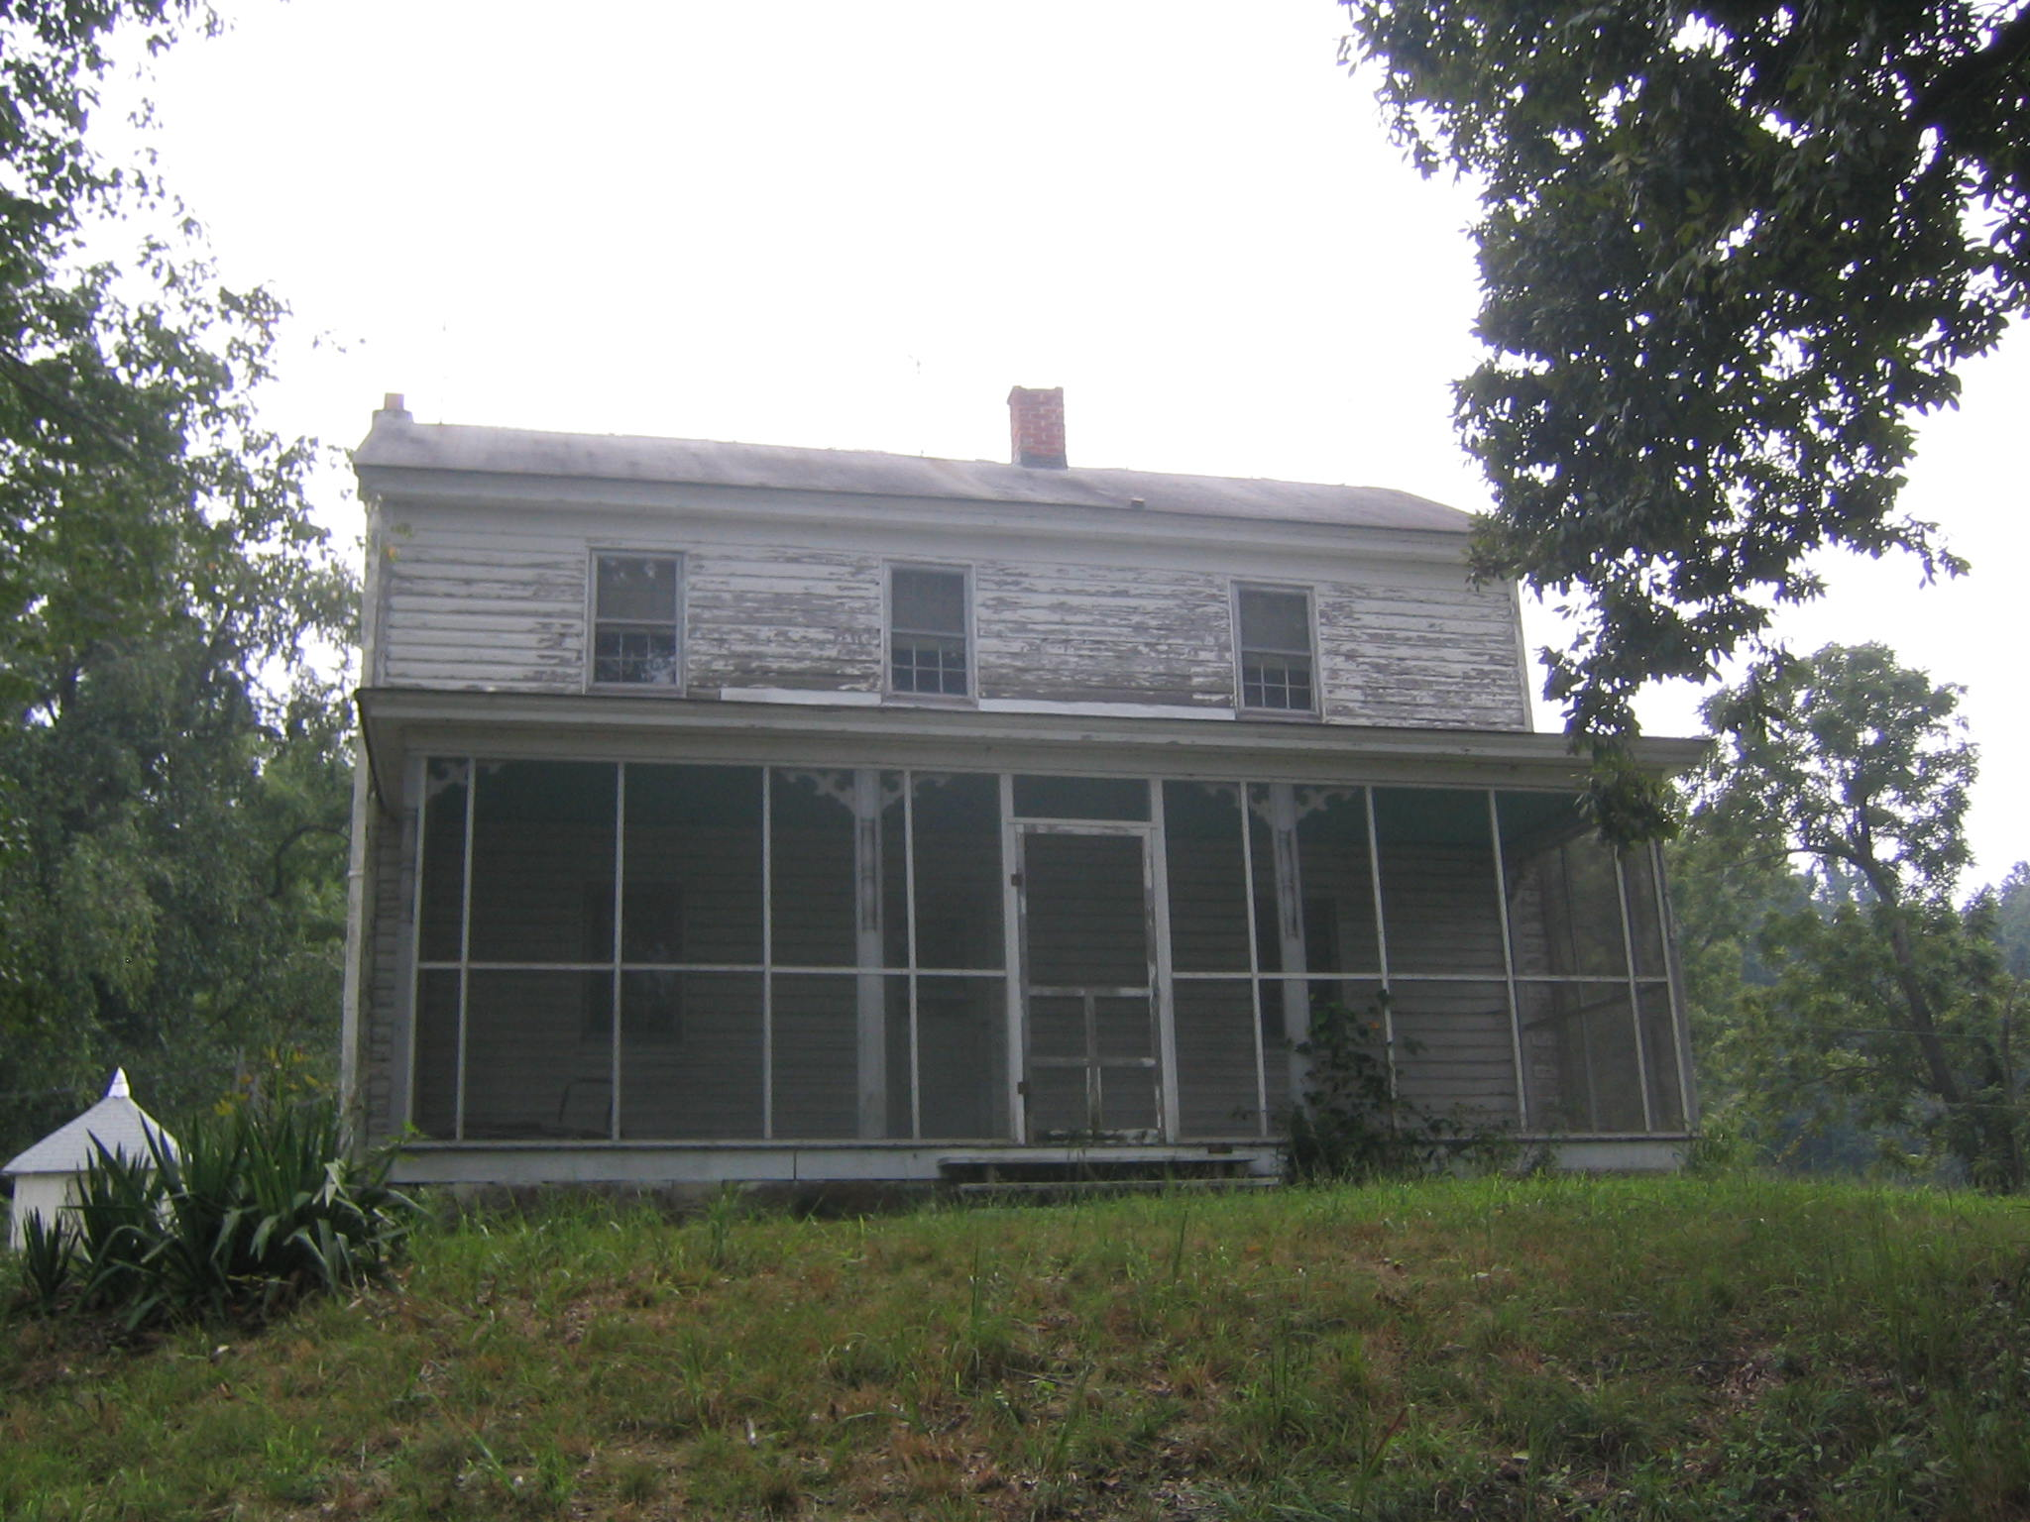

Photo: Sansbury-Griffith House, view of façade (northwest elevation), looking southeast. (August 2007)

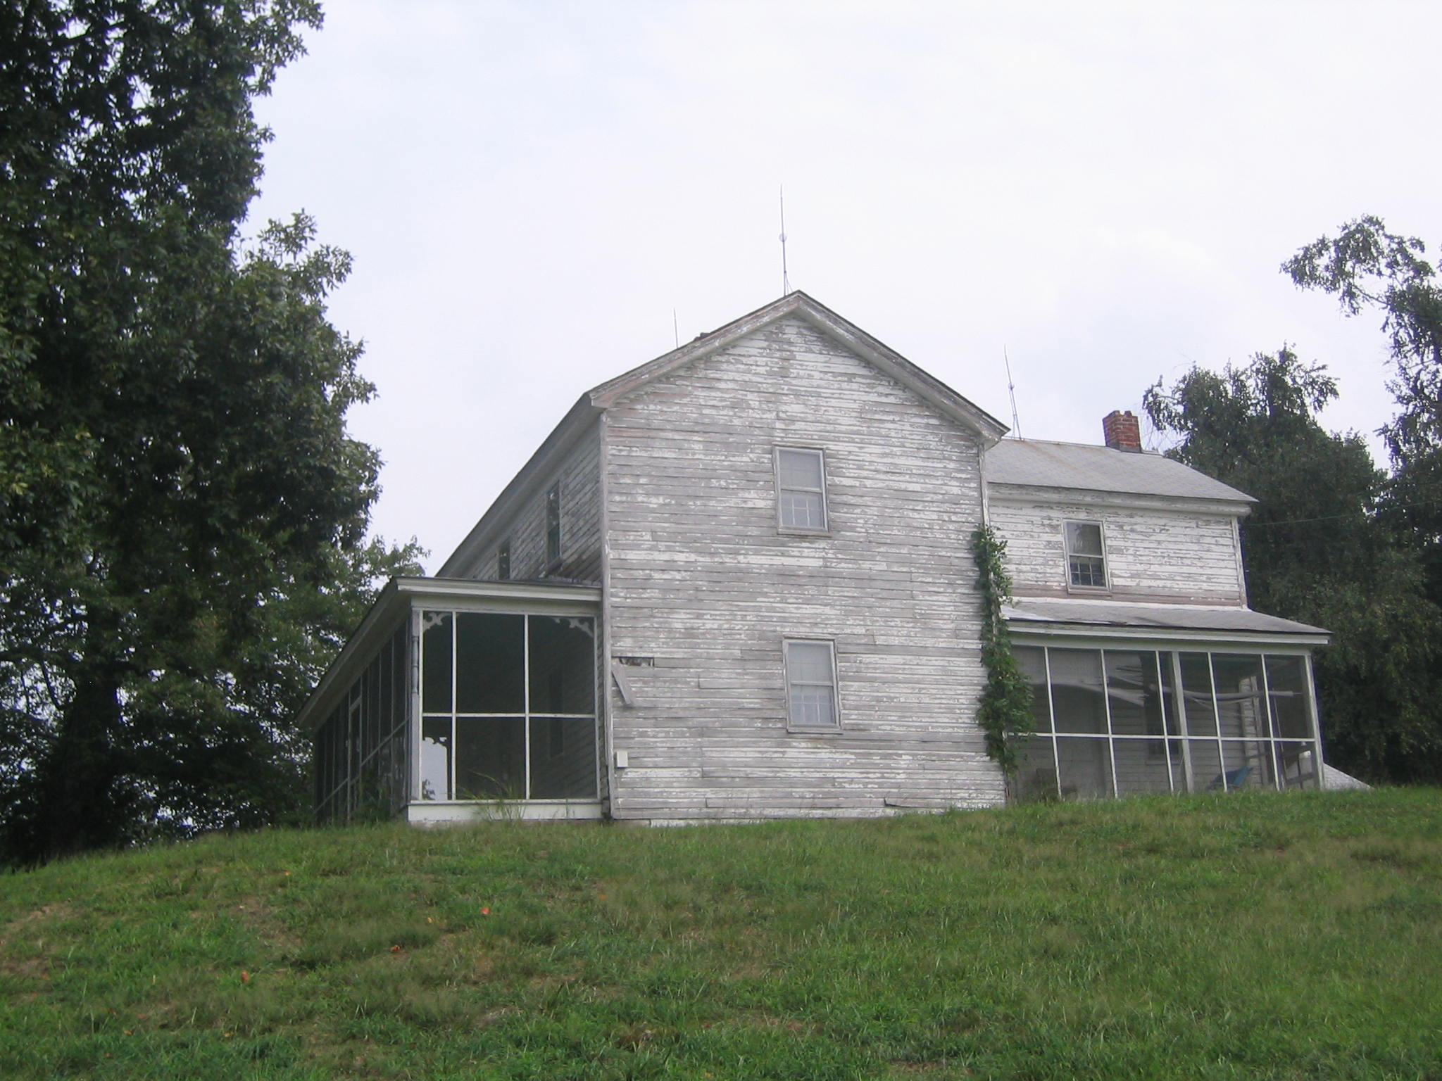

Photo: Sansbury-Griffith House, view of the southwest (side) elevation, looking east. (August 2007)

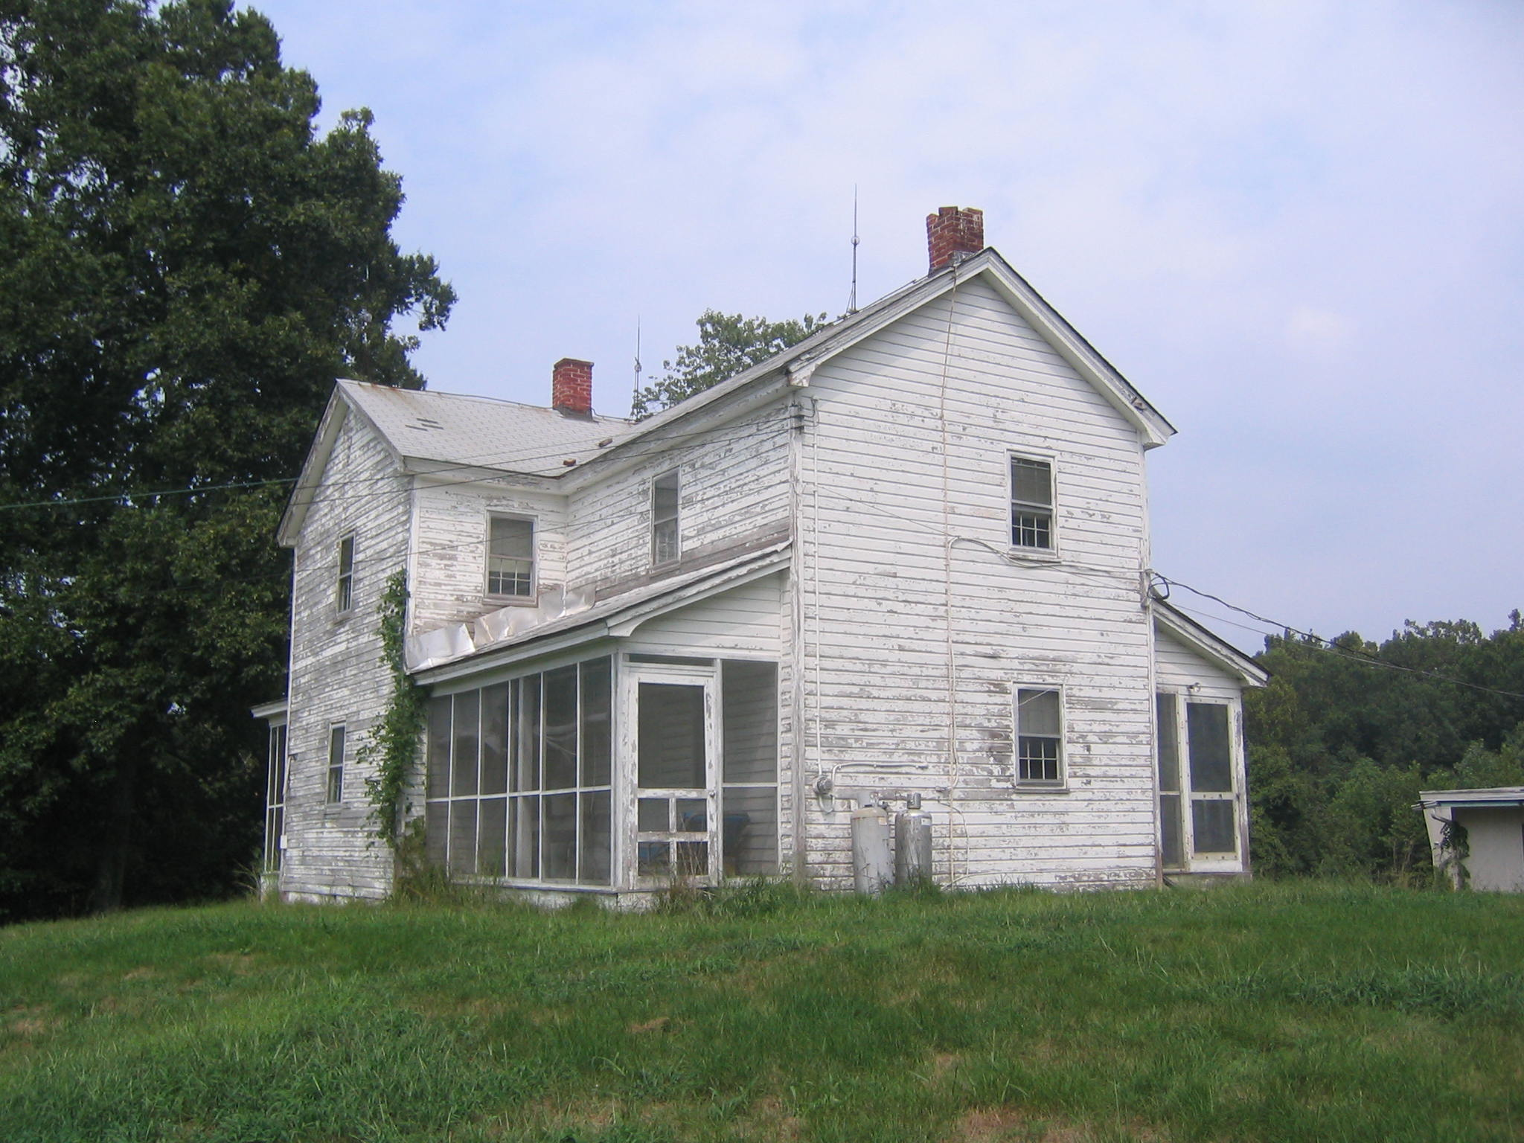

Photo: Sansbury-Griffith House, view of the southeast (rear) elevation, looking north. (August 2007).

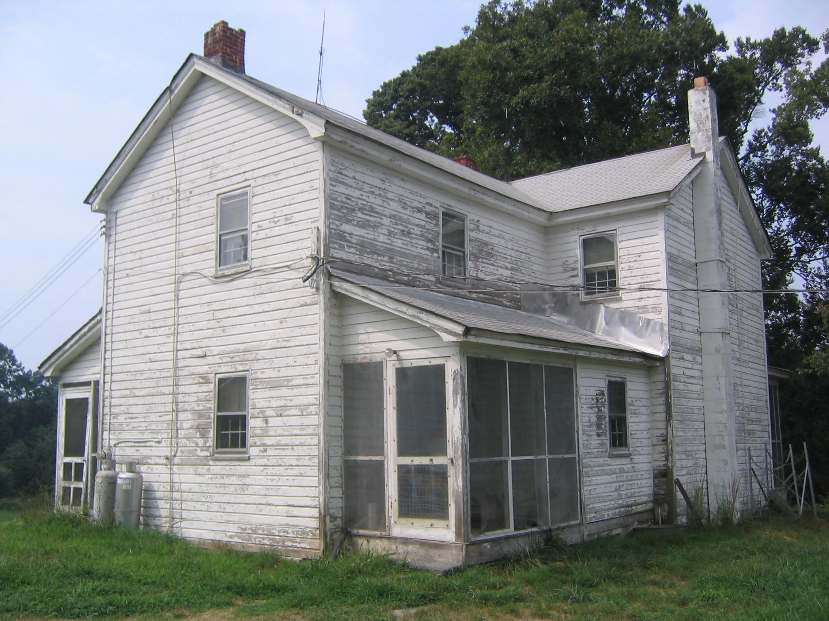

Photo: Sansbury-Griffith House, view of the northeast (side) elevation, looking northwest. (August 2007)

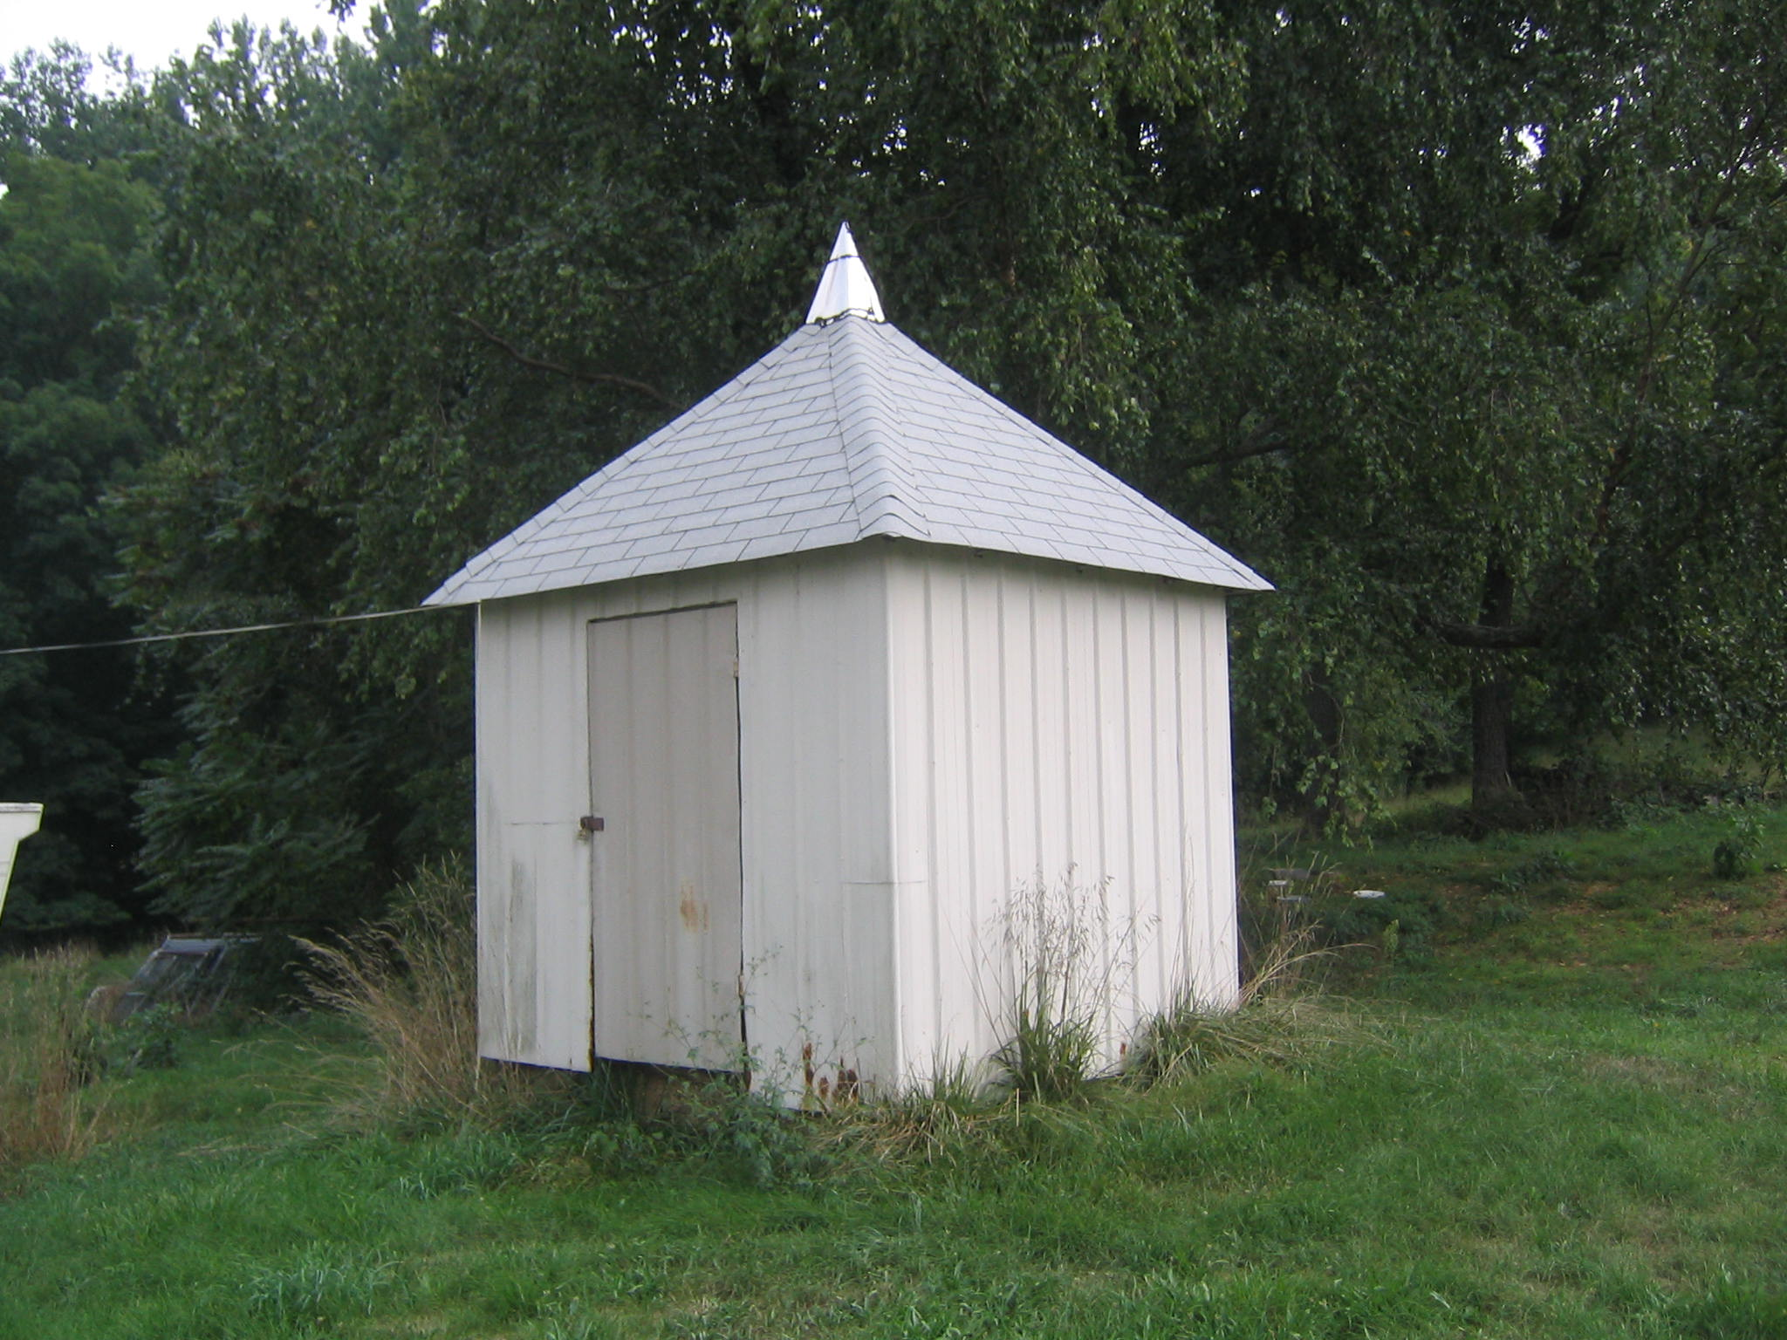

Photo: Meat House, view of the façade (northwest elevation), looking east. (August 2007)

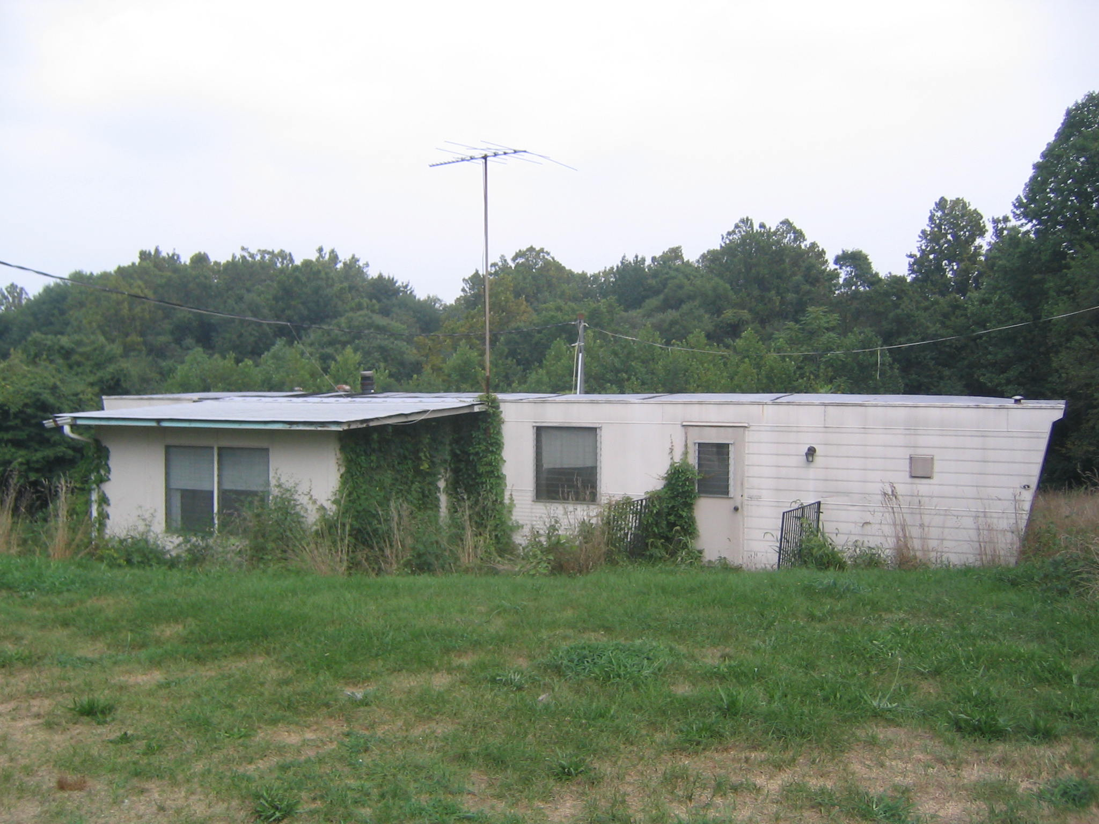

Photo: Mobile Home, view of the façade (southwest elevation), looking northeast. (August 2007).

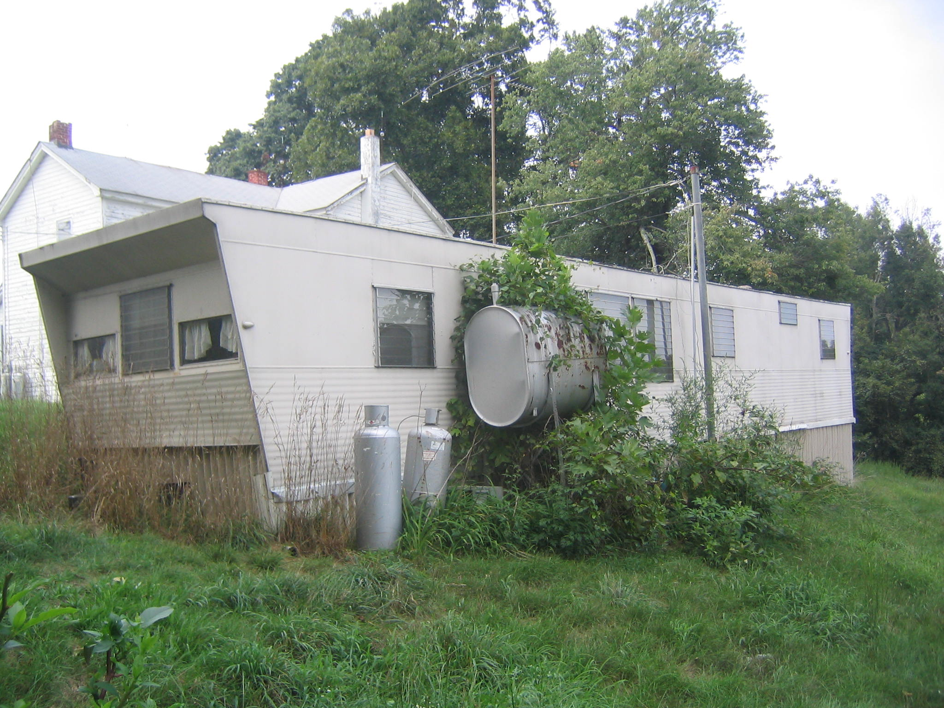

Photo: Mobile Home, view of the northeast (side) elevation, looking northwest. (August 2007)

Marina King, “Sansbury-Griffith House,” (PG: #82 B-6) Maryland Historical Trust Historical Trust State Historic Sites Inventory Form (1981), 8:1.
Marina King, “The Tobacco Industry in Prince George’s County, 1680-1940,” in Historic Contexts in Prince George’s County: Short Papers on Settlement Patterns, Transportation and Cultural History (Upper Marlboro, MD: Maryland-National Capital Park and Planning Commission, 1991), 69-71.
King, “The Tobacco Industry,” 69-71.
Maryland-National Capital Park and Planning Commission and the Prince George’s County Planning Department, Historic Sites and Districts Plan (1992), 53.
Maryland-National Capital Park and Planning Commission and the Prince George’s County Planning Department, Historic Sites and Districts Plan (1992), 53.
Smithsonian, Anacostia Community Museum, “The Plummer Family and Slavery in Maryland,” http://anacostia.si.edu/Plummer/Docs/JKWright_Paper.pdf (accessed October 25, 2007).
Maryland-National Capital Park and Planning Commission, Historic Contexts in Prince George’s County (1991), 43.
G.M. Hopkins, Atlas of Fifteen Miles Around Washington, Including the County of Prince George Maryland (Philadelphia: G.M. Hopkins, C.E., 1878); Simon J. Martenet, “Atlas of Prince George’s County, Maryland, 1861,” Adapted from Martenet’s Map of Prince George’s County, Maryland (Baltimore: Simon J. Martenet C.E., 1861).
Samuel B. Hance to Richard H. Sansbury and John M. Sansbury, Prince George’s County Land Records, HB 4:554.
1860 U.S. Federal Census, District 2, Prince Georges, Maryland, Series M653, Roll 478, Page 0, Image 414.
John M. Sansbury to Francis O. Sansbury, Prince George’s County Land Records, WAJ 1:41.
Samuel Fowler vs. John M. Sansbury, Prince George’s County Land Records, Equity 1209.
C.C. Magruder, Trustee to Richard H. Sansbury, Prince George’s County Land Records, WAJ 1:351.
Richard H. Sansbury and Sarah E. Sansbury to William W. Duley, Prince George’s County Land Records, JWB 1:413.
1880 U.S. Federal Census, Marlboro, Prince Georges, Maryland, Series T9, Roll 513, Family History Film 1254513, Page 45.4000, Enumeration District 122, Image 0092, William W. Duley.
Baltimore Trust and Guarantee to Louis Griffith, Prince George’s County Land Records, Equity #2541.
1920 U.S. Federal Census, Marlboro, Prince George's, Maryland, Series T625, Roll 674, Page 15A, Enumeration District 71, Image 329, Louis Griffith.
1930 U.S. Federal Census, Marlboro, Prince George's, Maryland, Roll 877, Page 12B, Enumeration District 9, Image 743.0, George Washington Griffith.
Marina King, “Sansbury-Griffith House,” (PG: #82 B-6) Maryland Historical Trust Historical Trust State Historic Sites Inventory Form (1981), 8:1.
Deed of Louis and Mary Frances Griffith to George Washington Griffith, Prince George’s County Land Records, 532:31.
1930 U.S. Federal Census, Marlboro, Prince George's, Maryland, Roll 877, Page 12B, Enumeration District 9, Image 743.0, George Eugene Griffith.

